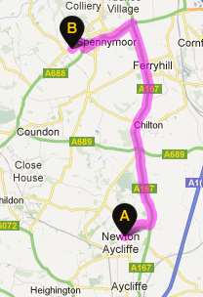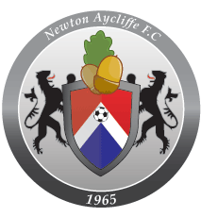

**Newton Aycliffe to Spennymoor – 8.9 miles – Saturday September 1st, 2012.**

|  |  |  |  |
| --- | --- | --- | --- |
| **NAME OF SPONSOR** | **CONTACT DETAILS** | **AMOUNT** | **TICK WHEN PAID** |
|  |  |  |  |
|  |  |  |  |
|  |  |  |  |
|  |  |  |  |
|  |  |  |  |
|  |  |  |  |
|  |  |  |  |
|  |  |  |  |
|  |  |  |  |
|  |  |  |  |
|  |  |  |  |
|  |  |  |  |

**Raising funds for Newton Aycliffe FC – Marching on Together!**

**Raise £100 – earn free entry to one home league game of your choice, including half-time hospitality (tea, cake and biscuits)**

**Raise £150 – earn free entry to two home league games of your choice, including half-time hospitality (tea, cake and biscuits)**

**Raise the most money out of all walkers, and win yourself a Newton Aycliffe replica shirt, signed by the entire 2012-13 squad.**