hat is your vision for Great
W
Aycliﬀe? How do you want to see it develop over the next 20 years? What aspirations do you have for future
generations? This is the chance for you to have your say, do not miss this opportunity!
This is why we need a
Neighbourhood Plan.

GREAT AYCLIFFE NEIGHBOURHOOD
PLAN

GREAT AYCLIFFE NEIGHBOURHOOD
PLAN

What can the Neighbourhood Plan achieve?

The Neighbourhood Plan can influence land and business use. It is a planning document which will make
it easier for developers to bring business and developments to the town and make Aycliﬀe Greater.

What do we need to know?

What’s good about Aycliﬀe? Once we know this we can protect it from changing
e.g. do you like the open green spaces, parks or general environment? If so we can protect these from development.

What needs to change? What are your issues, what needs to improve?
Would you like to see more facilities, better choice of housing, more jobs? Once we know this we can look
at putting planning policies in place that can help this happen.

Welcome
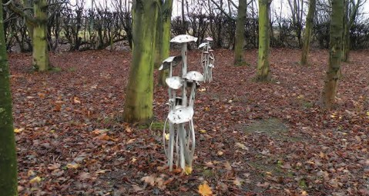
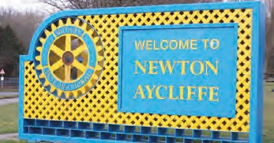

The Questionnaire
This questionnaire is available online at
www.great-aycliﬀe.gov.uk on the Neighbourhood Plan page if you
or other members of your household would like to complete the
form electronically.

You do not have to complete the whole questionnaire. Each page has a diﬀerent heading. If that topic isn’t important to you then don’t fill it in.

DO fill in any page which you feel should be dealt with in the
Neighbourhood Plan.

Your views are very important to this process.

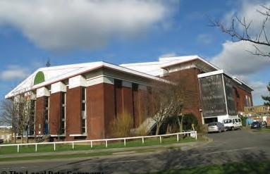
All completed questionnaires will be entered into a prize draw the first prize being £100 a second prize of £50 and a runner up prize of £25.

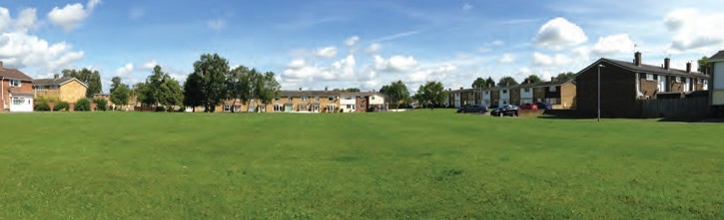

of open space, nature reserves and allotments, sports pitches, play
areas, parks and gardens and the planning of trees. It can also support
the promotion of renewable energy projects, such as solar energy.

1 Is the environment important to you?

Extremely important Important Not Important Very Unimportant

If you feel this isn’t an issue for you, please move on to the next topic.

2 Should the Neighbourhood Plan protect our green spaces or allow development e.g. housing, community or parking facilities on these green spaces?

Green spaces | Keep  (tick) | Why? | Development state all or part | What development?
Baliol Green
Travellers Green
Lee Green
Kemble Green
Clarence Green
Rufus Green
Trevor Green
Maling Green
Fenhall Green
Atkinson Gardens
(Aycliﬀe Village)
Other:
Unnamed greens: Please specify name of road or postcode e.g. Heild Close. Central Avenue, Old Elmfield School site etc
Un-named green spaces | Keep  (tick) | Why? | Development state all or part | What development?

3 Would you like to see future housing development include green spaces in keeping with the rest of the town?

Strongly agree Agree Disagree Strongly Disagree

4 In addition to green spaces we also need to know what other things are important to you:

 | Important | Why?
More allotments
Renewable energy
Solar panels
Planting of trees
Other:

is influence the design and type of the housing we require. Over 2000 homes are planned to be built in Great Aycliﬀe over the next 20 years.

5 Do you think it is important we have a say around the type of housing Great Aycliﬀe requires?

Extremely important Important Not Important Very Unimportant

If you feel it is not important please move onto the next topic.
To fully understand your future housing needs can you please answer the following:

6 Do you think your home meets your personal needs, now and in the future?

 | Yes | No
Currently
For the next 5 years
For the next 10 years

7 If you are planning on moving can you tell us when you are likely to move, what type of housing you may require and also how many bedrooms?

Housing type Number of bedrooms
 | Now | 5 years | 10 years | Where in Aycliﬀe?
Starter homes (Low Cost)
Shared ownership – you buy half you rent half
Bungalows, please tick which
1) Privately owned or;
2) Social Housing e.g. livin
3) Private rental
Homes for families with younger children
(Mid-range) please tick which
1) Privately owned or;
2) Social Housing e.g. livin
3) Private rental
Larger family homes, please tick which
1) Privately owned or;
2) Social Housing e.g. livin
3) Private rental
Single person flat / apartment. Please tick which
1) Privately owned or;
2) Social housing
3) Private rental
Homes for the retired / mature residents
Sheltered housing for the elderly
Sheltered housing for the disabled
Live in / work units

Housing continued . . .

8 Thinking about future housing development, what do you think is important?

 | Important | Why?
Design of the house
Ensuring open green spaces are included in the design
Renewable energy/solar panels
Other:

9 Are there any areas of land which you think could be suitable for housing development?
Please try and be as specific as possible to help us locate it on a plan.

......................................................................................................................................................................................................

......................................................................................................................................................................................................

......................................................................................................................................................................................................

......................................................................................................................................................................................................

10 Any other comments?

......................................................................................................................................................................................................

......................................................................................................................................................................................................

......................................................................................................................................................................................................

......................................................................................................................................................................................................

......................................................................................................................................................................................................

......................................................................................................................................................................................................

......................................................................................................................................................................................................

......................................................................................................................................................................................................

......................................................................................................................................................................................................

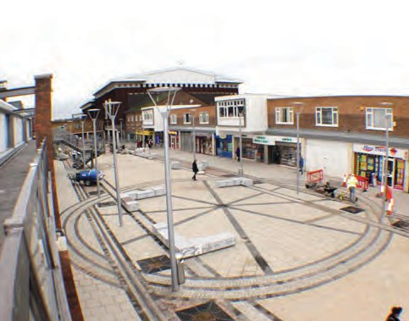
Retail

The Neighbourhood plan can develop planning guidance which encourages the improvement of the shopping provision within Great Aycliﬀe. National
and Local Planning policies require any retailer or investors to look at any town centre location first to see if their needs could be met there. If there are no suitable facilities within the town centre or nearby, then and only then can they look to any sort of out of town provision.

11 Do you feel it is important for the Neighbourhood Plan to address Retail?

Extremely important Important Not Important Very Unimportant

If you feel this is not an issue for you please move on to the next topic.

The County Durham Plan states that the County will support appropriate proposals that can improve the evening economy in Newton Aycliﬀe Town Centre e.g. Bars/Restaurants/Evening Entertainment.
12 Do you think this would be successful in Newton Aycliﬀe? YES/NO

13 Comments: ............................................................................................................................................................................

.................................................................................................................................................................................................

.................................................................................................................................................................................................

.................................................................................................................................................................................................

.................................................................................................................................................................................................

14
 | Never, Please say why | Daily | Weekly | Monthly
Do you use the town centre to shop?
Do you use your local shopping centre?
e.g. Cobblers Hall.
Please state which one

.............................................................

15

16 What do you shop out of town for? ...........................................................................................................................

17 Which shops do you use? Circle all that apply:

Tesco | Wilkinsons | Boots | Boyes | Argos | Post Oﬃce | Heron Foods | Aldi
Savers | Pound  Stretchers | Co-op | Sainsbury  (Cobblers Shops) | Select | Bon Marche | The Money  Shop | Pet Shops
Vets | Cobblers/ Neville Parade | Hairdressers | Travel  Agents | Hot Food/ Takeaway | Card Shops | Café | Bike Shop  Neville Parade
Shoe  Zone | Homeplan  DIY | Newsagents | Estate  Agents | Tanning Salon | Dry  Cleaners | Local/Small Businesses e.g. love thy cupcake | Bookmakers
Florists | Banks | Local  Chemist | Opticians | Local  Butchers | The Learning  Centre | Brighthouse | Other? Please give details

Retail continued . . .

18 Were you aware of the range of shops present across the town? YES/NO

19 Do you Shop online? YES/NO

If yes, tell us what you usually shop online for? ......................................................................................................................

20 What would encourage you to use the Town Centre more often? Circle all that apply:

Cafes | Events | Arts/craft  displays | Fun days | Bars | Restaurants | Diﬀerent shops | Pop up shops (local businesses)
Click and collect (Buy online but collect in store) |  |  | Other? Please give details

21 | Is there anything else you would like to tell us?  ........................................................................................................................................................................................................
 | ........................................................................................................................................................................................................
 | ........................................................................................................................................................................................................
 | ........................................................................................................................................................................................................
 | ........................................................................................................................................................................................................
 | ........................................................................................................................................................................................................
 | ........................................................................................................................................................................................................
 | ........................................................................................................................................................................................................
 | ........................................................................................................................................................................................................
 | ........................................................................................................................................................................................................
 | ........................................................................................................................................................................................................
 | ........................................................................................................................................................................................................
 | ........................................................................................................................................................................................................
 | ........................................................................................................................................................................................................
 | ........................................................................................................................................................................................................
 | ........................................................................................................................................................................................................
 | ........................................................................................................................................................................................................

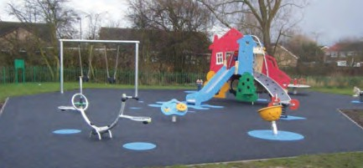
Service & Facilities

We would like to gather your view about the services and facilities that are currently available in Great Aycliﬀe or could be provided in the future.

22 Do you feel it is important for the Neighbourhood Plan to address our services and leisure facilities?

Extremely important Important Not Important Very Unimportant

23 If you feel this isn’t an issue for you, please move on to the next topic.
Education

 | Suﬃcient Y/N | Insuﬃcient? Why?
Pre-School/Nursery
Primary School
Secondary School

 | Easy to Access Y/N | Diﬃcult to Access - Why?
Further/Higher
Education
Adult Education

24 Community Facilities:

 | Which community facilities do you use? Please tick. | If not, why not, please tell us why, please tell us why not.
Woodham Community Centre
Agnew Community Centre
School Aycliﬀe Community Centre
Neville Parade Community Centre
Burnhill Methodist Church
St Clare’s
Evangelical Church/Horndale
Aycliﬀe Village Hall
Other

25 Do you know what activities go on in these centres? YES/NO

26 How would you prefer to find out about what activities are available, please circle your preference?

Facebook / Newton News / Aycliﬀe Today / Community Centre

Posters in Notice Boards / Town Council Newsletter

27 Is there any area of the Town which lacks, or is short, of community facilities? YES/NO

If yes, where?...........................................................................................................................................

Service & Facilities continued . . .

28 Health Provision:

 | Which one? | Are there any barriers to accessing these and why?
Are you currently registered with a Doctor’s Surgery?
Are you currently registered with a Dentist’s Surgery?

29 Do you use any other health service e.g. Pioneering Care Centre? YES/NO

30 If yes, please tell us which one: ..................................................................................................................................

31 If you have problems accessing any health service, please tell us why?

................................................................................................................................................................................................

................................................................................................................................................................................................

................................................................................................................................................................................................
32 Leisure Facilities:

 | Do you use Y/N | If no, say why?
Newton Aycliﬀe Leisure Centre
Oak Leaf Sports Complex
Ruﬀ and Tumble
Planet Leisure
15 Parks/Play areas, please state which ones
One Gym
Aspire Fitness
Crossfit
Youth & Community Centre
Oak Leaf Golf Course
Woodham Golf Course
Other, please give details

33 If you travel out of town to access leisure facilities, please tell us what and where do you travel to?
................................................................................................................................................................
34 In terms of facilities what are we lacking?............................................................................................
................................................................................................................................................................
35 Is there anything else we need to know? .............................................................................................
................................................................................................................................................................

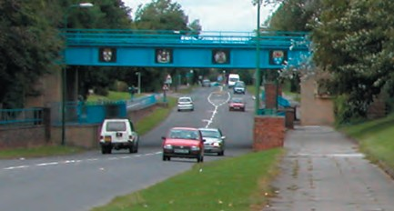
Transport

Transport and access (including issues around public transport, roads, cycling, walking and access for disabled people) can be a key element of a Neighbourhood Plan and can cross over into a number of other areas.

36 Do you feel it is important for the Neighbourhood Plan to address Transport issues?

Extremely important Important Not Important Very Unimportant

If you feel this isn’t an issue for you, please move on to the next topic.
37 Please answer the following:

Issue | Yes? Tick | Where?
Reduce speed of vehicles
Improved bus/train times
Parking congestion - schools
Lack of parking - business
Parking congestion - business
Cycle paths are they fit for purpose? Can you travel across the town/business park
Footpaths need to be improved
Traﬃc calming measures are needed?
HGV traﬃc is a problem
Disabled access is needed
38 How do you travel?

 | Daily | 2-3 times per week | A few times a month | Occasionally
Car
Bus
Foot
Motorbike
Bicycle

39 How many cars are in your household? ................................................................................................
40 Do you have adequate parking at or near your home? YES/NO
41 How could this be improved?................................................................................................................

................................................................................................................................................................

42 Is there anything else you wish to let us know about? ........................................................................

................................................................................................................................................................

................................................................................................................................................................

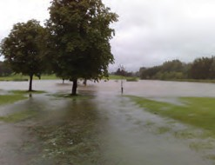
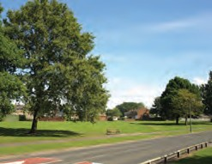
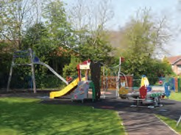
43 When considering planning applications, Durham County Council can require developers to contribute to improvements in the Parish. Which of the following improvements do you think would be of benefit to the Parish? (Please tick all that apply)

Aﬀordable housing

Recreational facilities

Public areas (e.g. Parks and Streets) Improved cycle paths
Community facilities
(e.g. Village/Community Hall Improvements)

Subsidised local bus services

Road infrastructure

Improved flooding prevention

44 Do you think any areas of the Parish need extra attention? (Please give details and locations)

Highways/road repairs ......................................................................................................................... Pavements and dropped kerbs ............................................................................................................ Road verges.......................................................................................................................................... Countryside footpaths ......................................................................................................................... Winter gritting...................................................................................................................................... Overgrown/neglected trees ................................................................................................................. Street lighting....................................................................................................................................... Sewers.................................................................................................................................................. Neglected properties ........................................................................................................................... The appearance of the parish .............................................................................................................. The approaches into the parish ........................................................................................................... Recreation facilities.............................................................................................................................. Vandalism ............................................................................................................................................ Litter..................................................................................................................................................... Fly-tipping ........................................................................................................................................... Anti-Social behaviour ........................................................................................................................... Crime ................................................................................................................................................... Other....................................................................................................................................................

45 What are the three best things about living in the Great Aycliﬀe area?

1.............................................................................................................................................................................................

2.............................................................................................................................................................................................

3.............................................................................................................................................................................................

46 Please rate the following in the Parish, with 1 being very poor and 10 being excellent

 | 1 | 2 | 3 | 4 | 5 | 6 | 7 | 8 | 9 | 10
Schools
Green Spaces
Leisure Facilities
Community Facilities
Housing
Health Provision
Retail Opportunities
As a place to live
As a place to bring up your children
As a place to visit
Employment Opportunities
Friendly
Safe

47 If you had to choose three things to change about your area what would they be and why?

1............................................................................................................................................................................................

2............................................................................................................................................................................................

3............................................................................................................................................................................................

48 What would be your VISION for Great Aycliﬀe in the future?

..............................................................................................................................................................................................

..............................................................................................................................................................................................

..............................................................................................................................................................................................

..............................................................................................................................................................................................

..............................................................................................................................................................................................

Great Aycliﬀe Neighbourhood Plan
www.great-aycliﬀe.gov.uk

As part of the Neighbourhood Plan questionnaire we are taking this opportunity to ask you about the Town Council and its services. It has been a number of years since the Parish Performance Plan had a full review and this is the right time to do it.

Some of the things coming out of the Neighbourhood Plan consultation may not be able to be addressed by planning policies and where ever possible these things will be included in the Town Council Parish Performance Plan or passed to the most appropriate organisation.

T1 The Town Council vision is to be “A quality Council, working in partnership, listening to and speaking up for the community, to bring excellent services to Great Aycliﬀe”
Do you think this is still a suitable vision for the Town Council to aim to achieve? YES NO

T2 If not, why not ...................................................................................................................................................

...........................................................................................................................................................................

........................................................................................................................................................................... The eight strategic aims to support the vision of the Town Council are:-
1. | To provide good quality governance and management of the Council.
2. | To manage the council’s finances and assets in a responsible manner.
3. | To provide accessible, aﬀordable leisure facilities and opportunities.
4. | To provide pre-school education as appropriate in Great Aycliﬀe.
5. | To contribute to the environmental improvement of Aycliﬀe by managing and developing parks, play areas and green spaces.
6. | To help and encourage partnership working to improve the services and facilities for the residents of Great  Aycliﬀe.
7. | To encourage the residents of Great Aycliﬀe to become involved in local democracy.
8. | To research information and make the case for Great Aycliﬀe.

T3 Do you feel these are still appropriate to meet the aims and aspirations of the residents of Great Aycliﬀe?
YES NO

T4 If not, why not ...................................................................................................................................................

...........................................................................................................................................................................

...........................................................................................................................................................................

T5 Please rate the following Town Council Services and facilities:

 | Very Good | Good | Average | Poor | Don’t Know
Fun in the Park
Parks and Play Areas
Pre-Schools
Allotments
Cemeteries
Environmental Areas
Oak Leaf Sports Complex
Civic Events
Oak Leaf Golf Course
Senior Citizen’s Excursions

Town Council Services continued . . .

As you are aware all local government organisations are being aﬀected by the Central Government cuts to funding. This is making the continued delivery of services in many areas diﬃcult although; this is not an immediate problem for the Town Council. However, it is important in the longer term that we ask what is important to the residents to be able to plan our work load, service delivery and future spending plans to respond to the priorities of the residents of Great Aycliﬀe.

Cost of Front Line Services | 2012/13 £ | 2014/15 £
Environment, Works and Street Equipment | 345,550 | 305,000
Parks, Sports Pitches and Play Areas | 330,500 | 218,950
Oak Leaf Sports Complex | 313,550 | 211,000
Community & Special Events | 143,050 | 134,050
Oak Leaf Golf Course and Driving Range | 87,250 | 40,600
Cemeteries | 59,200 | 52,200
Pre Schools | 40,200 | 32,150
Allotments | 11,300 | 9,700
Cost of Running Front Line Services | 1,330,600 | 1,003,650

T6 Make three choices, from the list below, ranking them in order or preference for which you see as the most important areas for continued service delivery.

Parks and play areas |  | Grass cutting and flower beds on  Town Council owned land
Public seating, bus shelters and  Litter bins |  | Fun in the Parks
Pre-school provision |  | Senior Citizens’ Excursions
Oak Leaf Sports Complex |  | Civic Events
Oak Leaf Golf Complex |  | Environmental Areas
Allotments

The Town Council portion of your Council Tax bill (for a Band A property) is only £139.45 per year.
T7 Do you think the Town Council provides value for money for their services? YES NO

T8 Are you satisfied with the work of the Town Council? YES NO

If not, why not? ..................................................................................................................................

............................................................................................................................................................

T9 Is there anything else you wish to tell us about? ..............................................................................

...........................................................................................................................................................

...........................................................................................................................................................

...........................................................................................................................................................

...........................................................................................................................................................

...........................................................................................................................................................

...........................................................................................................................................................

About You

It would help us to analyse your answers if you tell us a little about yourself

How many years have you lived in Great Aycliffe?

Up to 2 2 -5 6-10 11-20 21-35 36-50 51-70 70+

Which age group do you fall in to?
Under 18 18-29 30-44 45-59 60-70 Over 70

Under 11 11-17 18-29 30-44 45-59 60-70 Over 70

Which best describes your household?

Single Couple Family Friends Retired Other

Do you or anyone in your household work in Aycliffe? YES/NO do you have any school age children? YES/NO If YES – please give age(s)
Where were you born?
Aycliffe Co Durham Elsewhere in UK Not in the UK

In order to help us understand the make-up of the people of Great Aycliffe please tell us to which of these groups do you consider you belong - please tick as appropriate

White Black/Black British

British Caribbean

Irish African

Any other White background Any other Black background

Mixed Asian

White and Black Caribbean Indian White and Black African Pakistani White and Asian
Any other mixed background Any other Asian background

Chinese and Any Other Ethnic Groups

PLEASE SEE OVERLEAF FOR PRIZE DRAW OPPORTUNITY

Prize Draw

If you wish to take part in a prize draw for completed questionnaires, please
provide your name, address and contact number below. This information will only be used for the Neighbourhood Plan.

Please return your form in the enclosed Freepost envelope by
FRIDAY 10th OCTOBER 2014

1st Prize £100 2nd Prize £50 3rd Prize £25

Name (please print)………………………………………………………………………………. Address…………………………………………………….………………………………………
……………………………………………………………………………………………………… Post Code (this is essential) ……………..……………………………………………..
Telephone………………………………………………….………………………………………

THANK YOU FOR TAKING THE TIME TO ANSWER QUESTIONS ABOUT GREAT AYCLIFFE NEIGHBOURHOOD PLAN

Designed & Printed by Newton Press, St. Cuthberts Way, Newton Aycliﬀe, Co. Durham DL5 6DX Tel. 01325 300212 - www.newtonpress.net

