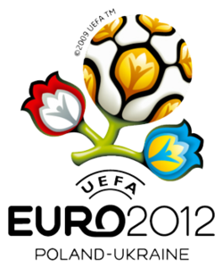
THE EURO 2012 EXPERT PREDICTOR
£1
75% of all monies pooled will be distributed in prize fund. 25% will be directed towards Newton Aycliffe FC.
in association with Newton Aycliffe Football Club
Group A | Group B | Group C | Group D
Poland | Holland | Spain | Ukraine
Greece | Denmark | Italy | Sweden
Russia | Germany | Ireland | France
Czech Rep. | Portugal | Croatia | England

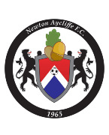

One point is awarded for each correct guess below. In the event of a tie, the tie-breaker question below will decide a winner. Should the tie breaker result in a tie, then the pool will be shared.
In the quarter finals, the winner of A will face the Runners-up in B, with the winners of B facing the Runners-up in A. This is concurrent in Groups C & D.
Most points (40%, or share of 40%)
Second (20%, or share of 20%)
Third (10%, or share of 10%)
Fourth (5%, or share of 5%)

Example pay-out
*1000 predictors sold

1st - £400
2nd - £200
3rd - £100
4th - £50

NAFC - £250
Winner Group A
Runner-up Group A
Winner Group B
Runner-up Group B
Winner Group C
Runner-up Group C
Winner Group D | 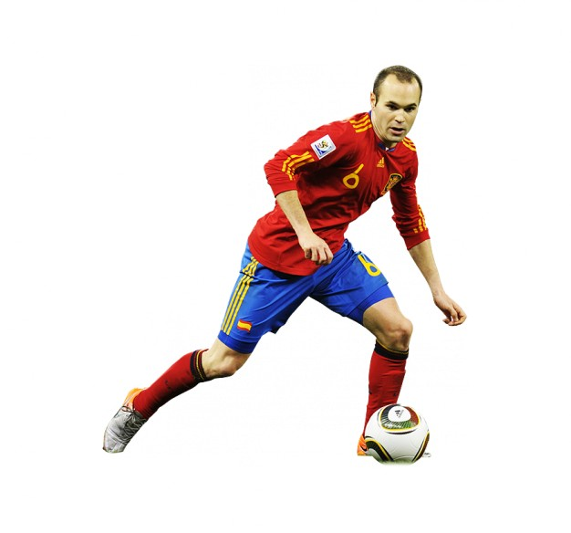
Runner-up Group D
Four semi-finalists
Runners-up
Tournament Winners
Top Goalscorer

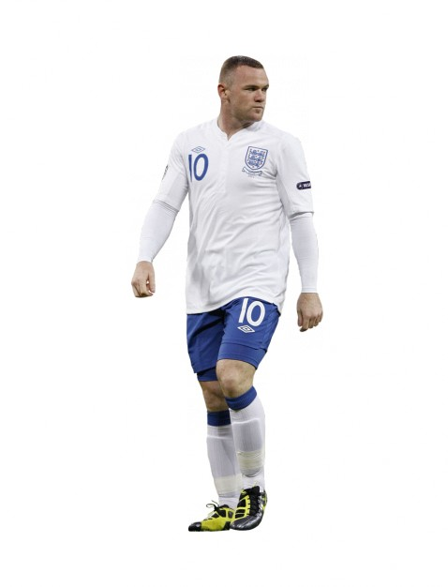

Tie Breaker – Total amount of goals to be scored during tournament (exc. penalty shoot-outs)
Bank Details:
Name: Newton Aycliffe FC
Acc/No: 41443240
Sort Code: 40-12-01
Bank: HSBC Bank
During Euro 2008 - 77 goals were scored in total.

Name: ........................................................................

Contact Number: .......................................................

